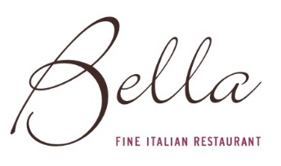
Pre-order form
Bella Restaurant Limited
Terms & Conditions
- Please confirm menu choices on pre-order form no later than 48h before your reservation.
- Pre-orders may not be changed unless you inform the restaurant 48h prior to your visit
- Drinks & bottles of wine can be pre-ordered or arranged to be on the table on arrival
- Please advise of any allergy, intolerance or dietary requirements
- Parties are required to be on time & we reserve the right to refuse late tables. Weekends, special days
all parties will have a maximum dining time of 2 hours
- For large parties a non-refundable, non transferable £10 per person deposit is required to confirm all reservations. All reservations will remain provisional until deposit has been received.
- Please note ONE BILL PER TABLE

Name of reservation: Date of reservation: Sit down time:

Name | Starter | Main | Side Dish | Dessert | Special Request
1.

2.

3.

4.

5.

6.

7.

8.

9.

10.

11.

12.

13.

14.

15.

16.

17.

18.

19.

20.

21.

22.

